1. Rewrite the following pseudocode segment using a loop structure in the specified language:

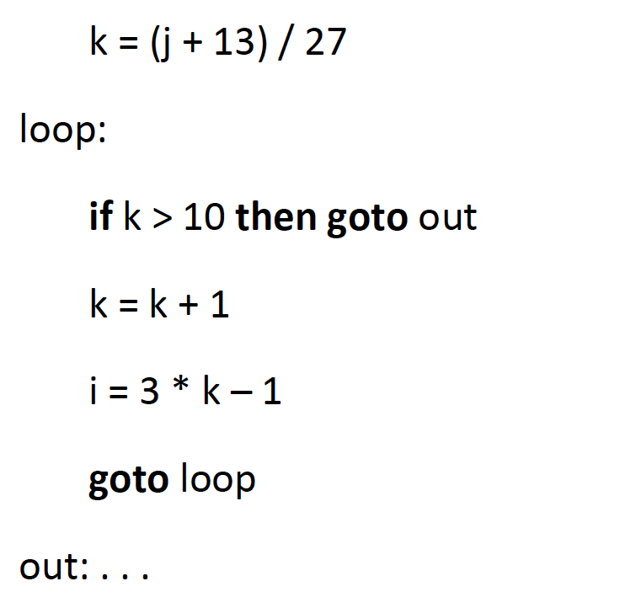

1. C, C++, Java or C#

Java

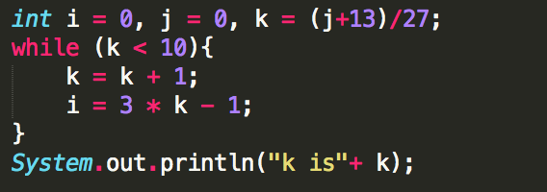

1. Python

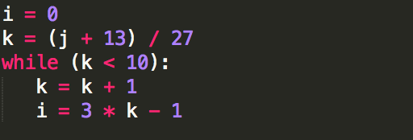

1. Ruby

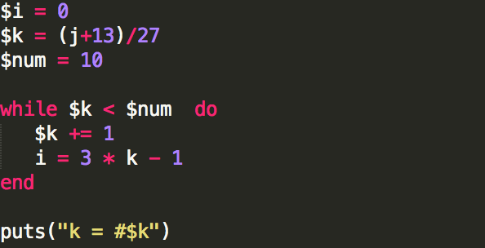

Assume all variables are integer type. Discuss which language, for this code, has the best writability, the best readability, and the best combination of the two.

Best Writability: **Python**

I reason that this is due to the short and brief syntax python has. There are also not much semi-colons and parenthesis’ in the syntax.

Best Readability: **Ruby**

Ruby is the youngest of the lot here and we can see evidently from the structure of its while loop syntax that you can read it as, “while k is less than num do … end” and that is very close to natural language than the other two.

Best of Both: **Java**

Java here being a language that is quite popular and widely used as an educational learning language, I believe this contributes to its level readability and writablity.

2. Rewrite the following code segment using a multiple-selection statement in the following language:

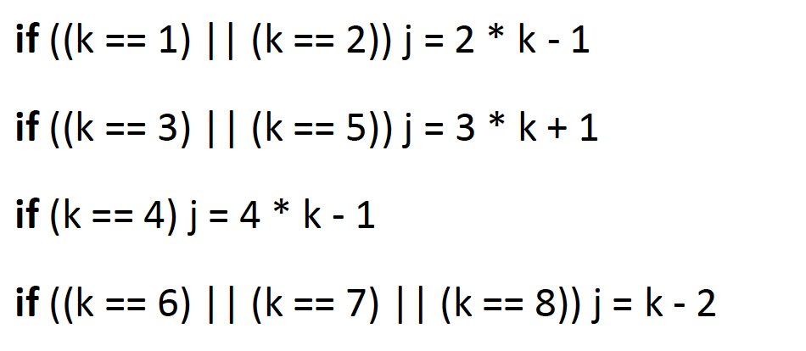

1. C, C++, Java or C#

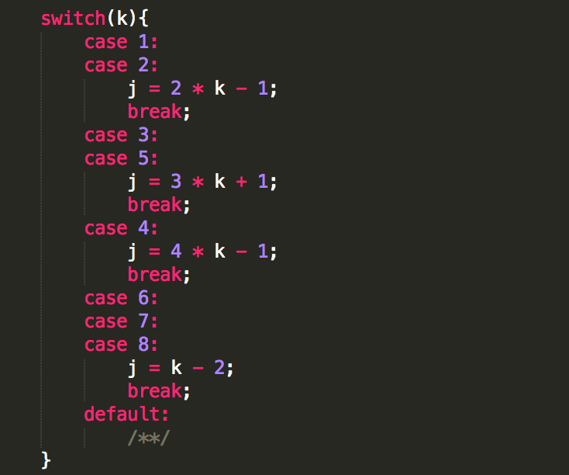

In Java we can basically see that one merit would be that you can perform code through switch cases as long as there is no break statement. For example case one will perform the same operation in case two but not case 3 due to the break dividing two and three.

1. Python

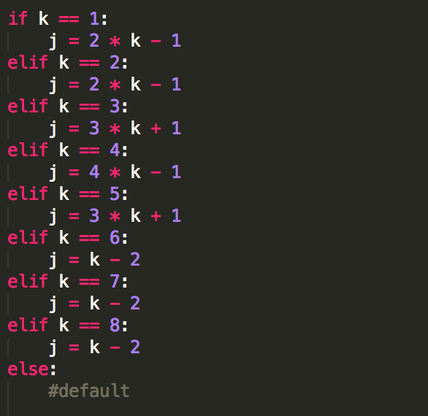

Python has no switch case structure but the same result can be obtained through if-elif-else. This makes python easier to debug since it goes through all statements.

1. Ruby

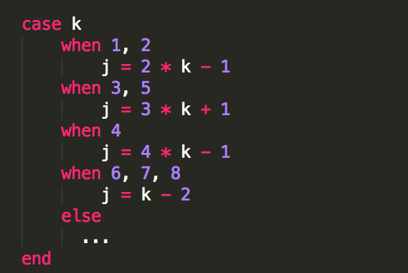

Ruby’s benefit is in syntax since common cases can be listed together only separated by commas to their fellow cases. This makes code shorter and concise than the previous two and saves space/lines. Also the readability of Ruby is again seen through the code.

Assume all variables are integer type. Discuss the relative merits of the use of these languages for this particular code.

3. In a letter to the editor of CACM, Rubin (1987) uses the following code segment as evidence that the readability of some code with gotos is better than the equivalent code without gotos. This code finds the first row of an n by n integer matrix named x that has nothing but zero values.

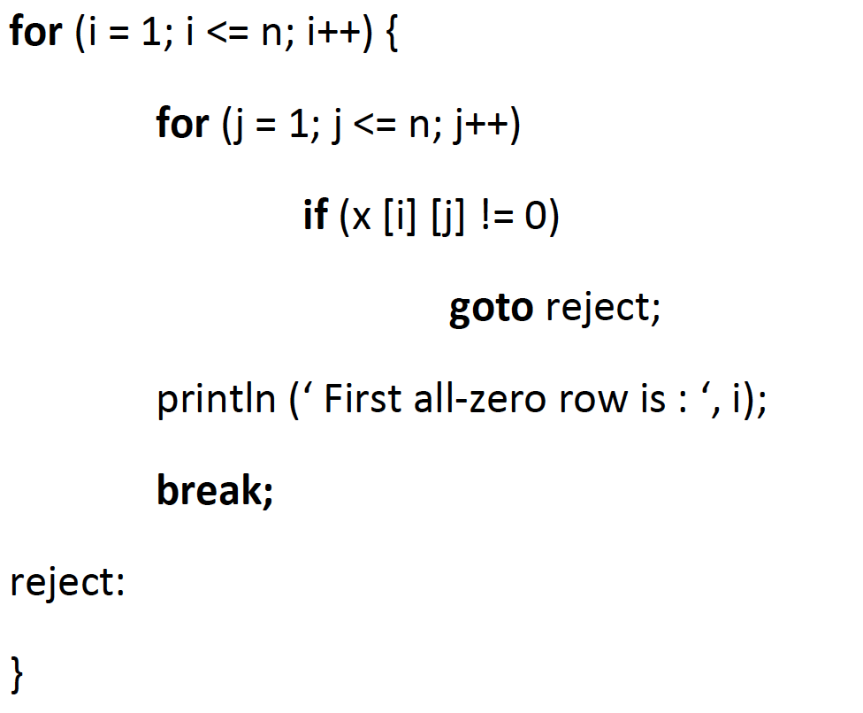

Rewrite this code without gotos in one of the following languages: C, C++, Java, or C#. Compare the readability of your code to that of the example code.

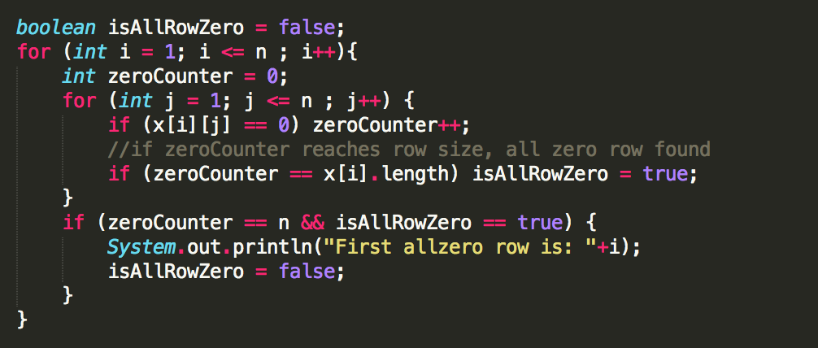

I will argue that the readability of my code is better than the example because the conditions for printing out the all zero row is clearly stated. The condition being if there are zero characters found are equal to the size of the row, then an all zero row has been found. As an added precaution, a Boolean for an all zero row [isAllRowZero] is also set in place. The code with gotos is harder to read and follow. This could possibly make it harder for the programmer to debug.